Project Design Phase-II

TechnologyStack

(Architecture&Stack)

|  |  |
| --- | --- |
| Date | 31October2022 |
| Team ID | PNT2022TMID43620 |
| ProjectName | NewsTrackerApplication |
| MaximumMarks | 4 Marks |

# TechnicalArchitecture:

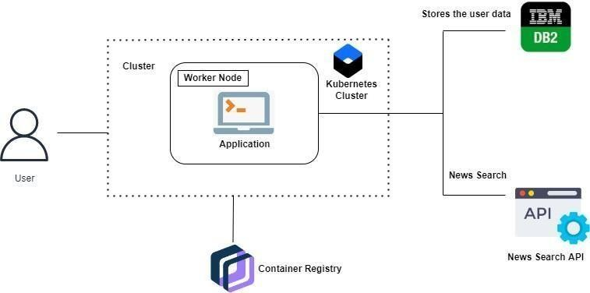

**ProjectWorkflow:**

* Theuserinteractswith theapplication.
* Registersbygivingthe details.
* Integratethe applicationwithnews APIs andstorethedatainthedatabase.
* Thedatabase willhaveallthe detailsandthe usercansearchthe newsbyusingasearchbar.

|  |  |  |  |
| --- | --- | --- | --- |
| **S.No** | **Component** | **Description** | **Technology** |
| 1. | UserInterface | Theusercaninteractwiththeapplicationtoknowaboutthetrendingnews | HTML, CSS, JavaScript /AngularJs/ReactJsetc. |
| 2. | ApplicationLogic-1 | Theapplicationcontainsthis  resourcegivesyoubasicunderstandingofFlask. | Flask. |
| 3. | ApplicationLogic-2 | The application contains thenewssub-divisionlike  geographical news, economicnews andsocietynews. | IBMWatsonSTTservice |
| 4. | ApplicationLogic-3 | Theusercanviewthegrowthof the economy in industrythroughgraph. | IBMWatsonAssistant |
| 5. | Database | Updatingoftrendingnewsare  storedintheMySQLdatabase. | MySQL,NoSQL,etc. |
| 6. | CloudDatabase | Withtheuseof cloud,media  coverage issue cannot beoccurred. | IBMDB2. |

# ApplicationCharacteristics:

|  |  |  |  |
| --- | --- | --- | --- |
| **S.No** | **Characteristics** | **Description** | **Technology** |
| 1. | Open-SourceFrameworks | Flaskisflexibleanddoesn’trequiretouseanyparticularprojectorcodelayoutusedin thisapplication. | Python-Flask |
| 2. | SecurityImplementations | This can be access only by the journalist. So,it isahighSecurity. | Containerregistry,KubernetesCluster. |
| 3. | ScalableArchitecture | News Tracker is associate-economic access becausehelpsto knowaboutthe dailyactivityoftheworld. | Containerregistry,KubernetesCluster. |
| 4. | Availability | This application will be available to the all theuser who areusingthis application. | Containerregistry,Kubernetes  Cluster. |
| 5. | Performance | Theupdatingoftrendingnewsoccurswithoutanyinterruption.So,itsperformanceisgood. | Containerregistry,KubernetesCluster. |